# Chapter 1

# Introduction

The project tourist guide will provides the various information about the place a person desire to such as living expenses , transportation cost , location etc. The software will help people who are wanting to visit but have no idea , by providing some of the information about places they are desiring to it can be about culture and market.

**Main Features of the application :**

* User will be allowed to create their profile and login to the application
* User will be allowed to view the contents and information they want to
* User will be allowed to share knowledge relating to culture , tradition and places
* Users will be allowed to provide their opinion and feedback.

Php (object oriented language) programming language will be used to develop the application .Some of the tools will be used for analyzing such as Data Flow Diagram , Rich picture and use cases etc and for designing such as UML diagram (class diagram ,Activity diagram , Sequential diagram ).

**Some of the goals or aims of an application :**

- Eradicate the communication gap between visitor and place

- Publicize the natural beauty ,biodiversity and places .

**Some of the technical objectives:**

Customer satisfaction

* Increase in revenue
* Make an diverse society

Some of the personnel objectives:

* Gain experience
* Learn the development methodology and different programming language
* Understand the working environment
* Time management

Some of the academic objectives are:

* To be competence and skilled
* Understanding different method and approaches

## Development methods

There are many development methodology such as :

* Agile Methodology
* Spiral Methodology
* Waterfall Model

I chose the waterfall model to develop my overall project which is a type of hard approach. It has an Standard to be followed while applying the approach . It provides some of features such as :

* Structural process
* Every process should be done through step by step procedure which make less chance of mistake
* Has it own standard
* Rigid Control
* Graphically representation of overall project For example DFD Data Flow Diagram

As Object Oriented method is an type of the waterfall model the development process will be done through the object oriented methodologies because the approaches is suitable for every medium to large scale project . It views models as an set of interacting objects . Provides some of the advantages such as :

* Reusability of analysis ,design , objects and programming
* System can be developed more rapidly
* Improved the consistency among the models developed
* Easy to understand
* Improved communication users and project development team

The development of the application is as well in object oriented programming language . Some of tools will used in development methods are :

- Data Flow diagram

- Use case diagram

- UML Diagram

- ER diagram

- Normalisation

Some of design pattern will be used are :

* MVC pattern (Model View and Controller) and Observer Pattern

# 

# Introduction

Analysis is to ask how something does what it does why it is as it is. A process of looking at the different part of a topic how they fit together and what action to take and which will be more reliable action. Analysis define the overall direction of the project that will taken while developing the project .

The activities involved in analysis are:

**Brain Storming** : Critical thinking what is needed and necessary in a project . For instance : classes , object ,requirements etc .

**Requirement gathering** : It is the most focused or attracted part of an analysis phase . The process involves four basic step :

* **Elicitation**: I ask question, you talk, I listen
* **Validation**: I analyze, I ask follow up question
* **Specification**: I document, I ask follow up question
* **Verification**: we all agree

**Feasibility study** : It involves some of the basic study such as :

* **Social**

Social factor mainly make an impact to our product because of the people choices ,culture ,religion and many other factors. Usually ,Social implication are seen in marketing campaign from we can gather the information about the people taste and flavor for example : Kathmandu is mostly famous for temple ,religious people could be attract .

* **Economic**

Their would not be more economic influence because the product is more to information factor than the economy. The product is mainly focused to provide information for free . Regarding to cost of developing software : - cost of operation ,cost of resources , cost of deployment .

**Cost Benefits analysis :**

**Benefits**

* Low implementation cost compare to normal individual consortium
* Easy to implement
* Mitigate the communication gap between the traveler and places
* Higher flexibility with number of alternative solution

**COSTS**

**DEVELOPMENTCOSTS**

·         **Hard ware Costs** -

* No need to purchase new hardware. The Personal hardware and existing resources in premises of the users will be used.

·         **Software costs -**

* Free & open source software will be used .

**Initial implementation Costs**

* No initial installation cost. (Free hosting).
* **Political**

Their would be problem on launching a product as an government product due to the political instability a part from that no problem launching as an private product .

* **Legal**

There may be some of legal implication such as restriction of features , some information to publicize which would make impact on our product (i.e lack of information). But mostly we are concerned about the legal and illegal activities.

* **Environmental**

Their wouldn't be any environmental disadvantage of the software .

* **Technical**

Technology has been more advance in 21st century . we will ablel to develop a quality software in a reliable cost . Our time will be saved as well .

I chose object oriented methodology as a development purpose of the software . It provides some of the advantages such as :

* Re-usability of analysis, objects, design and programming
* Improved communication among users, analysts, designers and programmers
* Increased consistency among the models developed
* Easy to understand
* More flexible and easier to make update in response to changing user requirements
* Systems can be developed more rapidly.
* Systems can often be developed at a lower cost.

In analysis we should be able to elaborate what our program is about to do and why rather than how. Analysis states what we need and what is the real scenario. It is about '"what '' and "why". We need to perform analysis because of the following reason :

* Identify man ideas or part of the task
* Describe main ideas on details
* Evaluation of the solution what is good and reliable to
* In order to understand the system , what we are going develop why the system is in that way ..

Tasks which is performed through the analysis process :

* Requirement engineering process: It is defined in a section three of a document which consist of two part functional and non functional requirement . Some of description is described in above topic requirements gathering.
* Use case: It is defined in a section 2 which states the behavior of a system and the user involved in system .
* Architecture: It is defined in section 5 of a document . It consists of two major tasks such as initial class diagram and system architecture.
* Prioritization: It is defined in section 4 . It consist of prioritization techniques such as MoSCoW prioritizing .
* Conclusion: it is defined in section 6

. which show overall summary of an documentation.

## Use Case :

The use case is one of the methodologies for system analysis to clarify , identify the system requirements . It is an behavioral model which show the function of an actor performs .A use case is a set of interaction between the system and the actors which will probably show the behavior of an actor .

Some of the characteristics are :

* Organizes a functional requirements
* Traces the path from trigger events to goals
* Models the system and actor interaction
* Describes the flow of events

It can be used in several stages of developing software such as gathering functional requirements ,testing software , and validating design .

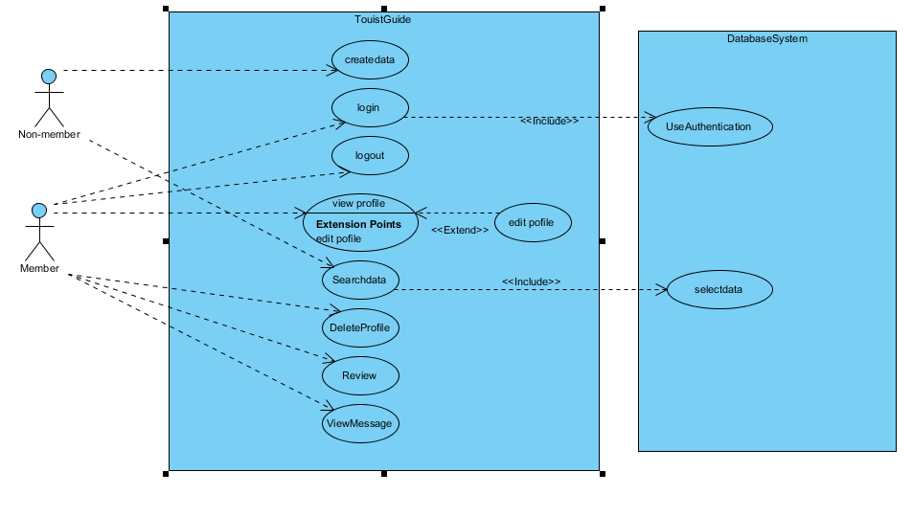

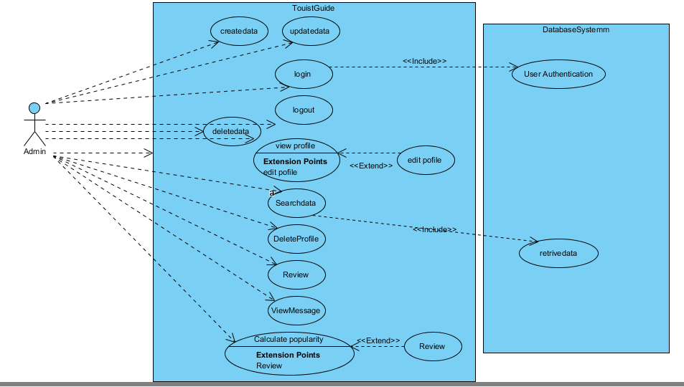

## Requirements Gathering

Functional Requirements :

Functional requirements define the functional activity of system or one of its subsystem . Any requirements which specifies the what system should do .

A fucional requirement will defines a specific behavior of a system when certain condition will be met . For example : send email when new user is register "Open a new account ".

|  |  |  |  |
| --- | --- | --- | --- |
| **ID** | **Title** | **Description** | **Rational** |
| R1 | User Sign up | A new user should be able to register through the web portal . The user must provide username ,password email and location | To acquire user credentials for login credentials . |
| R2 | User authentication | A user should be able to login with his or her existing email and password . Appropriate message shoud be provide to user whether credentials is valid or not | Validation of users whether s/he is valid user or not  To maintain user security and privacy |
| R3 | Review | A user should be able to give a feedback either rate the places or comment or both | To acquire user feedback inorder to calculate the popularity of places |
| R4 | Search data | A user should be able to search data they desire to | To provide easy and fast access of data |
| R5 | Send message | A user should be able t send message .Their should provide email , name and message | To acquire user response towards our site |
| R6 | Create Tourism information | Admin should be able to upload the created information regarding to the places. The information should be authentic | To deliver required information for users |
| R7 | Update Tourism information | Admin should be able to update data in order to maintain data integrity | To maintain data confidentiality |
| R8 | Update profile | User should be able to update profile | To recreate user profile |
| R9 | View Message | Admin should be able to view message sent by users | To analyze the user response and impact of the site |
| R10 | Delete | User should be able to delete their profile and admin should be able to delete the unauthentic data | Accountability and non repudiation |

**Non functional requirements** :

In any information system , non functional requirement will as wel play the vital role to determine the success of that particular information system .The non-functional requirement will provide environment and atmosphere to achieve the functional requirement successfully . We have identified several non-functional requirements , which is essential to our information system .

* **User Friendliness**

User friendliness is most important part of our system because the system is generally focus on public either could be technical person or non-technical person . So , it is most essential to be maximum user friendly(easy to use) .Our goal is to provide comfortable and flexible system .

* **Secure**

Security is an one of the major concern about every information system . Without the proper implementations of security ,we will be unable to provide the information system product to the users . We are planning to develop user logins , user authentication and system logbooks and many other features to make our system more secure and maintain our privacy .

* **Accuracy**

The information system should be very rigorous because we have to build a trust relationship between the user and our system . For example : if we provide false information about the places , cost of living then the traveler may get into some trouble like lack of money , lack of information about the place .Therefore , we are expecting to provide accurate system at the end of project .

* **Reliability**

Most crucial matter of a system is reliability .The system should able to evolve its reliability along with the mature system by providing rigorous solution and details which enhances the user satisfaction .

* **Availability**

The should be easily and freely accessible at any moment to all the users .

## Prioritization

MoSoW prioritization is a technique for helping to understand the priorities . The letters stand for

* **Must have**
* **Should have**
* **Could have**
* **Wont have the time**

In a project where time is fixed , understanding the relative importance of thing is vital to making progress and tracking the deadlines .

The reasons we use MoSCoW prioritization is for problem characterizing with simply saying that the requirements are of low , medium and high importance .The priorities will be specific if we use MoSoW prioritization .

|  |  |  |  |
| --- | --- | --- | --- |
| Must Have | Should Have | Could Have | Won't have |
| User Sign up | Send message | Bar chart |  |
| User authentication | Delete tourism data | Map navigation |  |
| Create tourism data | Delete profile |  |  |
| Update tourism data | Search tourism data |  |  |
| Update profile | View message |  |  |
|  | Report |  |  |
|  |  |  |  |

## Architecture

The art or practice of designing or building . We can describe an archecture as a type of model which shows off why the system is being build what system going to do and how it is going to do it .

The purpose of architecture is to :

* Clarify the system
* Overview of system how the system's going to work

### System Architecture

System architecture is a generic adhere to handle the objects called "systems" in a way which supports the structural properties of those objects . It describes three aspects :

* Why ? = sense
* What ? = function
* How ?= composition

I chose MVC architecture to handle my project as a model, view and controller which will segregate the business logic and the client logic part . There is more of loose coupling rather than tight coupling which make the system more reusable and maintainable , testable .

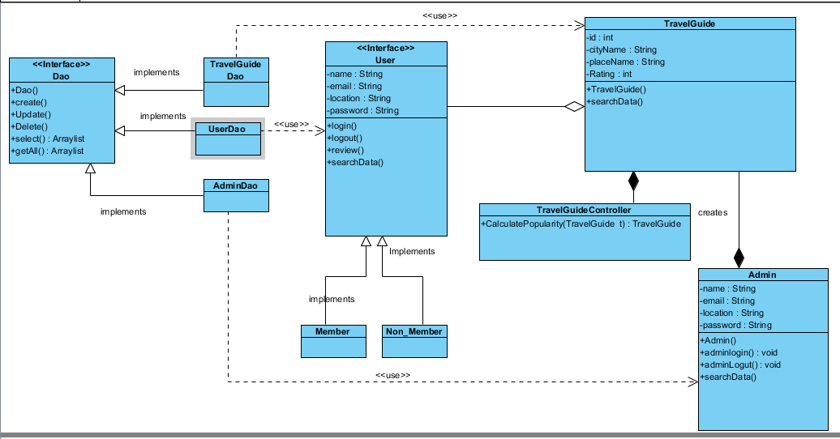

### Initial class Diagram

Class diagram is a static diagram . it represents the static view of the sytem . It is not only just for describing or visualizing or documenting the different state of the system but also to construct the executable code for the system .Class diagram shows the collection of classes , interfaces assocation and constraint .It is also known as well structural diagram

The purpose of class diagram :

* Analysis and design of static vie of the system
* Elaborate responsibilities of system
* Reverse and forward engineering

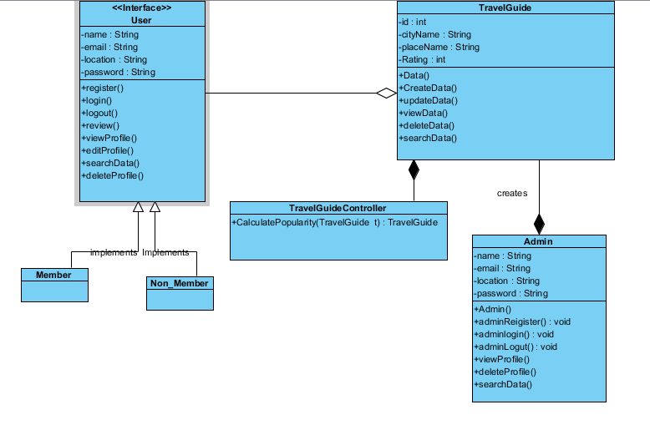

# Conclusion

As per the proposal is presented with the requirements of the project .In analysis is done in more technical way through segregation of the analysis in varies part . As a need of the project the analysis is provided in the above section .

# Chapter 2

# Introduction

Design is a graphical representation of a model .The process of transforming user requirements into some suitable analog which helps in software coding and implementation .

Software Design moves the concentration from problem domain to solution domains.

**Software Design Level**

* **Architectural Design** : It is the highest abstract version of the system that defines the software as a many interacting components .
* **High level Design :** It is a concept of architectural design into abstracted vie of modules and sub-systems and depicts their interaction. It recognizes the structure of system and their relation and interaction among the components .
* **Detailed Design :** It deals with the implementation part of what is seen as a system and in the previous two design . it defines logical structure of modules and their interfaces to communicate ith other modules .

**Modularization of Design**

Modularization is a technique to divide a software system into multiple discrete and independent module , which ae expected to be capable of carrying out tasks independently.

Advantages of modularization

* Easier to maintain smaller components
* Division program based on functions aspects
* Level of abstraction in the program
* Components can be aspects
* Concurrent execution
* Security aspects

**Verification of Design**

The output of software design process are :

* Design documentation
* Pseudo-codes
* Detailed logic diagram
* Process diagram
* Detailed description of functional and non-functional requirements

The implementation of a software depends upon the output of design

A good design is important for good software design ,accuracy and quality .

# Structural model

Structural modelling depicts the static features of a system .

They consist :

* Class diagram
* Object diagram
* Component diagram

Structural model represents the framework for the system and the framework is the place where all objects and components exist. For example the class diagram , component diagram ,deployment diagram are part of structural modelling .Class diagram is widely used structural diagram . It never describes the dynamic behavior of the system .

**Class diagram**

Class diagram is a static diagram . it represents the static view of the sytem . It is not only just for describing or visualizing or documenting the different state of the system but also to construct the executable code for the system .Class diagram shows the collection of classes , interfaces assocation and constraint .It is also known as well structural diagram

The purpose of class diagram :

* Analysis and design of static vie of the system
* Elaborate responsibilities of system
* Reverse and forward engineering

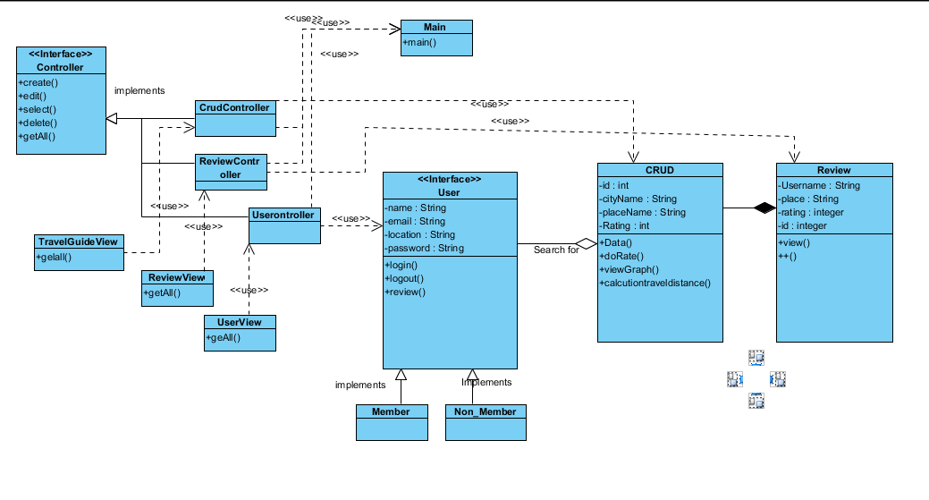

**ER Model**

It is a conceptual model.it is the type of a relational database model based on the notion of real world entities and relation among the entities. We can depicts the real world scenario into ER model . It createsset of entites along with their attributes , a set of constraint rules and relationship among them .

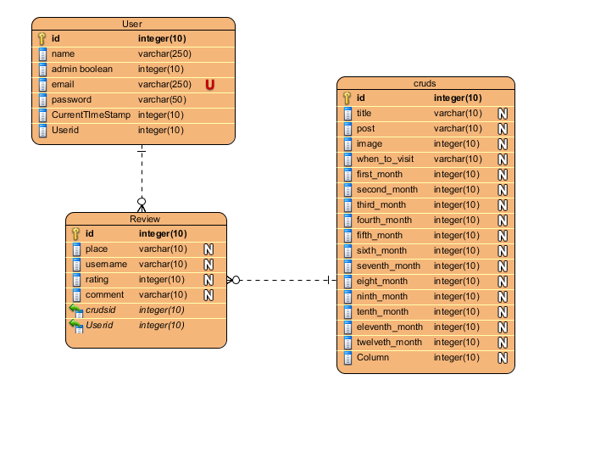

**Data Dictionary**

Data dictionary is the information about data . It is often referenced as metadata repository . It is created with DFD model of software program and is expected to the updated whenever DFD is changed or updates .

Data dictionary contains information about the folloing

* Data flows
* Data Structure
* Data Elements
* Data Store
* Data processing

# Behavior Model

Behavior model describes the interaction between the object of the system . It represents the interaction among the structural diagram . it shows the dynamic nature of the system .

Some of the diagrams are :

* Activity diagram
* Interaction diagram
* Use case diagram

**Activity Diagram**

Activity diagram is an important diagram in UML to describe the dynamic behavior of the system.

Activity diagram is generally like a flowchart which represent the flow of one activity to another activity. The activity can be elaborated as an operation of the system.

The control flow is drawn from one operation to another. This flow can be branched , concurrent o sequential. Activity diagrams deals with the all type of flow control by using different notation such as fork, join, etc.

**Purpose of Activity Diagrams**

The basic purpose of activity diagram is same as other four diagrams. It depicts the dynamical behavior of the system. Other diagrams are used to show the message flow from one object to another but activity diagram is used to show message flow from one activity to another.

Activity is a specific operation of the system. Activity diagrams are not only used for describing the dynamic behavior of the system, but also used to construct the executable system through the use of forward and reverse engineering techniques.

The purpose of an activity diagram can be described as −

* Draw the activity flow of a system.
* Describe the sequence from one activity to another.
* Describe the parallel, branched and concurrent flow of the system.

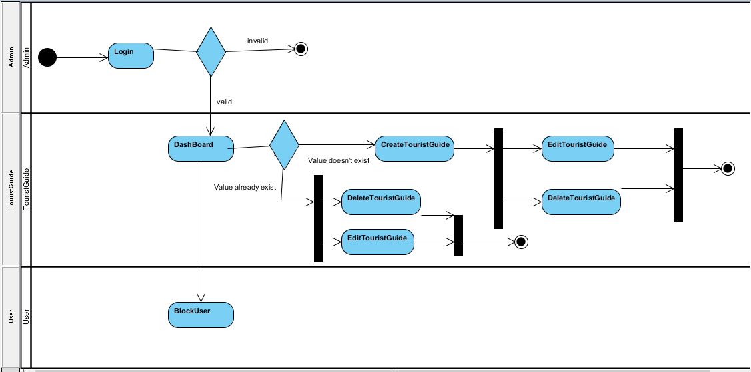

**Figure : 2 Activity**

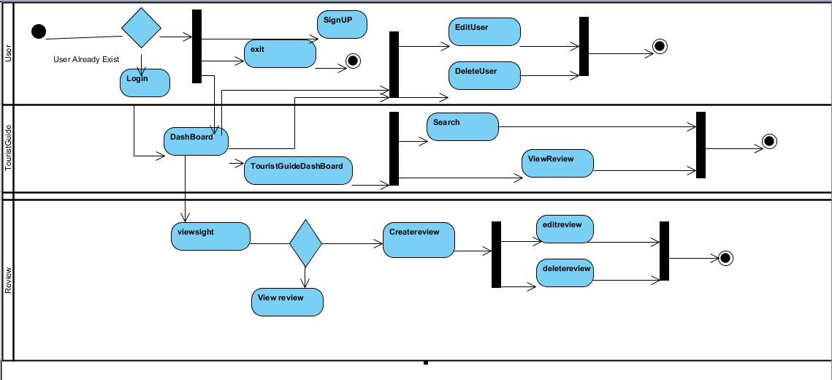

**Figure 3 : activity**

**Sequence /Interaction Diagram**

By term Interaction, it is made clear the diagram is used to elaborate some types of the interactions among the varies elements or objects in the model. This interaction is a part of the dynamic behavior in system.

This interaction is represented in UML by two diagrams known as **Sequence diagram** and **Collaboration diagram**. The basic purpose of both the diagrams are similar.

Sequence diagram explains on time sequence of messages and collaboration diagram explains on the structural organization of the objects that send and receive messages.

**Purpose of Interaction Diagrams**

The purpose of interaction diagrams is to visualize the interaction between objects of the system. Hence, the solution is to use different types of models to capture the different aspects of the interaction.

Sequence diagram is used to depicts the dynamic nature but from a different point of view.

The purpose of interaction diagram is −

* To capture dynamic behavior of the system.
* To describe message flow in the system.
* To describe structural organization of the objects.
* To describe interaction among objects.

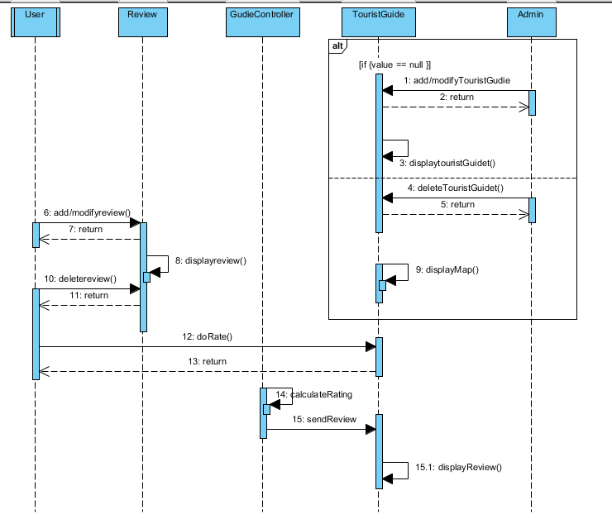

**Figure 4 :sequence diagram**

**Conclusion**

All of the required diagram has been drawn for the project which provides ore clear vision about the project how it's going to interact and function. The describes the project scope as well .

# Chapter 3

# Implementation

Introduction

This section covers the whole solution development phase of the application. And the deployment strategy of the project .Use of the programming language and deployment platform and development environment .

Programming language(s)

PHP is use to develop the solution for the project .As the project is about web development php provide more flexibility in that case .And it does not require and particular IDE .More compatibility language .And several other has been used such as javascript and content management language html , css etc . Php is mainly used for the server side scripting . And others for client script . Php is developed by Rasmus Lerdorf .it is a general purpose and sever side scripting language .

Development environment

You should write about:

_ Standard libraries

Image

Mail::send()

Create()

Save()

Function()

CurrentTimeStamp()

Geolocation

Distance matrix

Aggregation function

Database Migrations

Auth

Register

_ Frameworks (testing frameworks, etc.)

Laravel framework (application development)

Phpunit testing

Laravel Dusk (Browser testing)

_ Your development platform

Apache Server(Web host)

MySqli (Database)

Apache Server(Database host)

_ Other CASE / design tools you have used

Visual paradigm for design purpose

Deployment strategy

Deployment Diagram 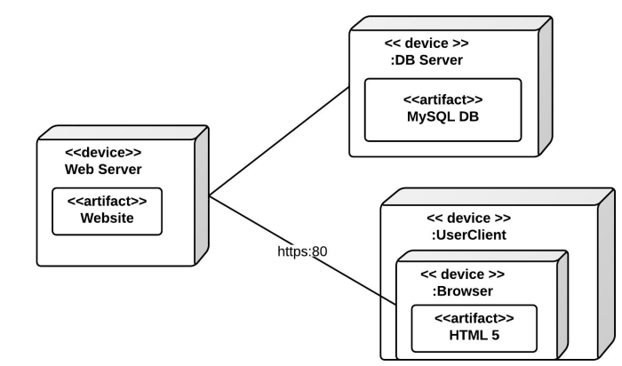

User training

The user will be provided training through the online session or seminar session . As well User guide will also be provided to the users inside the website with help service.

To explore the use of the website in what cases the application is beneficial for the user the users training is needed

After the release of the websites the training session will be start . The training session will be of five hours

Conclusion

The development environment ,deployment strategy and development platfrom are descrided in the above session as per the project is develop and planned to be deployed . The programming language has also been descried why t is used and what its benefits.

# Chapter 4

# Testing

Software Project Test Plan

**Purpose**

The Purpose of test document is to outline test strategy ,test cases and test approah for the TravelGuide Project .The document includes test approaches, resource allocation for test and estimation schedule.

**1.Introduction**

The section describes the objectives of the testing .The Framework will be to test for inorder to automated the testing which makes easy for solution tester to tests the software , More cost effective and timely efficient.

1.1 Test Objectives

The objective of test cases is to provide coverage of software requirements ,quality data validation and conformance of system .

Validate the software In what condition migh fails to work

Conformed that whatever the software does it does right .

Finding bugs and fixing it

**Features to be tested/not be tested**

This section mainly focuses on the function requirements testing rather than the non functional testing . It identifies all the features and the combination of features to be tested as well describes the features not to be tested.

Features to be tested

-Features developed in house

Components developed with in a team will be conformed through testing for example UAT , Functional testing etc

- Features develop by outsource vendor

Outsourced components used in our projects where the solution testing team hold the primary responsibilities to validate and conform will to be tested.

Ooutsourced components to de develop in our project where vendor hold it responsibility will not be tested as a features by the tester . Rather the test will be reviewed and check the pass/fail criteria .And will be re tested

Features not be tested

- Off the shell components

It is assumed off th shell component as evaluated and conform. the pros and cons properly weighed out th components of software.

- Framework provided features (which is already been tested )

It is assumed the framework IPR holder has tested the coomponents of the framework before releasing it .

- Infrastructure features

The components which are out of scope of the projects, for example database , server ,internet etc

Some level of test will be done such as configuration of database ,server and connection establishment of software .

**Testing Materials (Software/hardware requirements)**

This section define the resources that will be needed while performing test and alllocation of resources for test which includes hardware requirements ,software requirements and other additional requirements which perhaps be needed while testing

Hardware required

To enable the testing in our device the requirements should be according to the framework documentation .

Web Browers installed in the device

We will be using cloud service

We will need Database server ,Web Server

Software required

- The software requirements are minimal .The MySQLi database ,Apache sever will be used for the solution testing which need to install , setup and configured . The software will be occuping some space of the system

- As a project is developed in a laravel framework we will be using laravel dusk which is an automated browser test and phpunit test for unit test which required internet connection established inorder to install the framework an update the configuration .

Special requirements

Additional driver may need to be install in the computer in order to use the some of the features of the frame which may require more memory more space .

**Pass/fail Criteria**

We will be using automate testing software such phpunit , Laravel Dusk which has their own pass/fail criteria .For eaxample if software pases it will show Green ,if it fails then red which show components is tests pass or fail .

**Test Approach**

This section defines the general method of testing processes . It elaborates the for reasons for selecting the different test strategies which we often to the varies part of the system .

General Test Strategy

Component and unit testing wil be carried out as they are developed . Test wil be executed with the automated test tools run against the components as individuals .

Unit test suite will b be used as an regression at the time of components integration testing .The integration testing will be run automated testing system .

Testing will require some of the tools such as phpunit , laravel Dusk which help in effecive and efficient testing.

Integration Test Strategy

As the features will be developed through top-down and bottom-up . The test strategy will also be plan to order the components development . It will use the botom -up integration teseting approach .

**Test Cases**

This section is a core of the test plan , Lists of test suites which are used during testing. Each test cases is described in details . Each execution of test will be in a Test Report document .

# Conclusion

As the development had finished the test has been planned for the system.The project is not be said as the final ystem until all of the test get passed . So, Test approaches , test cases are define to conform that the all of the test get passed and the produc is ready to get deployed .

# Chapter 7

# Conclusion

The project is divide into is divided into six different section chapter 1 to chapter 6. The project implemented following the SDLC (Software Development lifecycle process) approach and little bit agile features as well for example such in Time estimation for the particular task .

Chapter 1 describes about the project scenario how how’s the project is going look like which includes several different tasks such as the project coverage project features , time estimation of the tasks in project .

Chapter 2 describes about the analysis of the project which involves the several key parts of the software such as the requirements analysis and requirement prioritizing .

In prioritizing of software we have followed the MoSCoW method . Several other tasks such as cost benefit analysis , segregation of the requirement as a functional and non functional which makes each in identifying the which type requirements is it either funcional or non functional is performed.

Chapter 3 is the design section which involve different logical diagram to be design such as class diagram .activity diagram,sequence diagram, Er diagram System architectural digram . The digram is drawn with the explanation of diagram to make clarification about the diagram For the design purpose we have use visual paradigm tools to draw varies diagram .

Chapter 4 is the heart part of the project which is the solution development part know as the implementation of the software . This part involve serveral different asks the as the use of the frame work has to described and the use of the programming has described .

Why it is used and what the standard libaries of the programming language .The implementation is done is php programming through the use of Laravel Framework .

Their is also diagram presented in documentation about the deployment of the software. How the software will be deployed .

Chapter 5 is the quality part which describes the quality of our software also known as the testing . Their are several different testing such as Black box testing ,Functional testing ,white box testing ,integration testing .We have perform unit testing and integration testing through the use of the laravel Dusk laravel framework new testing feature. Testing includes several different parts such as test plan ,pass fail criteria , test suites . The segregate the features with the term features to be tested and features not to be tested which more flexibility in testing the product

Several issues where introduced during the implementation time and testing time of the product such as browser issues . Software issues , coding issues and testing issues and Time issues .Neverthless ,The project has been completely finish with the complete as per the requirements and tested .

# Future Work

The software is based on the more informative and data critical part instead of the commercial parts .so, future work for the software will be data related how provide more useful data and how to make the use of raw data electively and efficiently. As the people nowadays being more more socialized in the public network we are planning outsourcing the data and make use of it .

In the future the software will be analyzing the data more critical way and analytical way which involves statistical analysis of data , Mathematical analysis , Economical analysis .In more precise term Data science .

Several other features will be added according to the users needs . As per they requested to do .According to the time need the new features will be introduced.

For now the our project is not about the what can user use do with the software it is about what user can take from th software . It is data .

# Test Script

RegisterTest

|  |  |  |  |  |  |  |
| --- | --- | --- | --- | --- | --- | --- |
| Test Case ID | Test Scenario | Test Steps | Test Data | Expected Results | Actual Results | Pass/Fail |
| TU03 | User  Register with valid data | 1. Go to page   /login   1. Enter Name 2. Enter Email 3. Enter Password 4. confirm Password 5. Click register | Name = Anan  Email = anan@admin.com  Password = aaaaa | User should be register | As Expected | Pass |
| TU04 | User register with invalid data | 1. Go to page 2. /regiter 3. Enter Name 4. Enter Email 5. Enter password 6. Confirm password 7. Enter Password 8. Click egister | Name = Anan  Email = ananadmin.com  Password = aaaaa | User should not be able to register | As Expected | Pass |

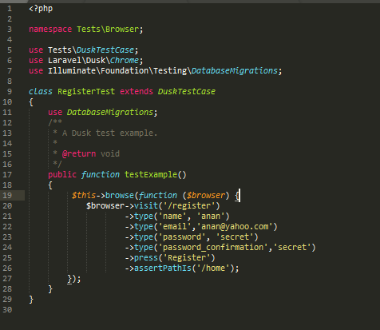

Figure 1 : Register Test Script

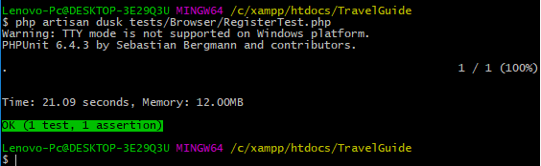

Figure 2: test result

LoginTest

|  |  |  |  |  |  |  |
| --- | --- | --- | --- | --- | --- | --- |
| Test Case ID | Test Scenario | Test Steps | Test Data | Expected Results | Actual Results | Pass/Fail |
| TU01 | Check Customer Login with valid Data | 1. Go to page   /login   1. Enter UserId 2. Enter Password 3. Click Submit | Userid = anan@admin.com  Password = aaaaa | User should Login into application | As Expected | Pass |
| TU02 | Check Customer Login with invalid Data | 1. Go to page   /login   1. Enter UserId 2. Enter Password 3. Click Submit | Userid = assdf Password = asdffg | User should not Login into application | As Expected | Pass |

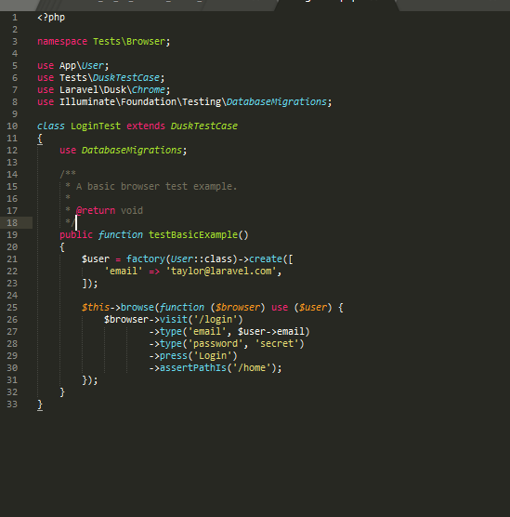

Figure 3 : Login test script

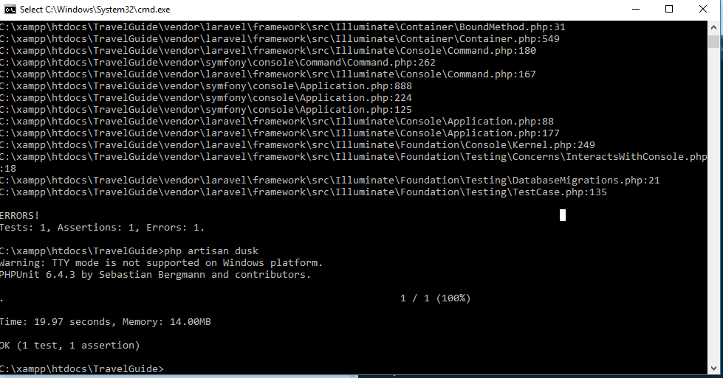

Figure 4:test result

LogoutTest

|  |  |  |  |  |  |  |
| --- | --- | --- | --- | --- | --- | --- |
| Test Case ID | Test Scenario | Test Steps | Test Data | Expected Results | Actual Results | Pass/Fail |
| TU17 | Check Customer Login with valid Data | 1. Go to page   /login   1. Enter UserId 2. Enter Password 3. Click Login 4. Click link Your User name Dropbox 5. Click Logout | Userid = anan@admin.com  Password = aaaaa | User should Logout from application | As Expected | Pass |
| TU18 | Check Customer Login with invalid Data | 1. Go to page   /login   1. Enter UserId 2. Enter Password 3. Click Login 4. Click link Your User name Dropbox | Userid = anan@admin.com  Password = aaaaa0 | User should not Logout from application | As Expected | Pass |

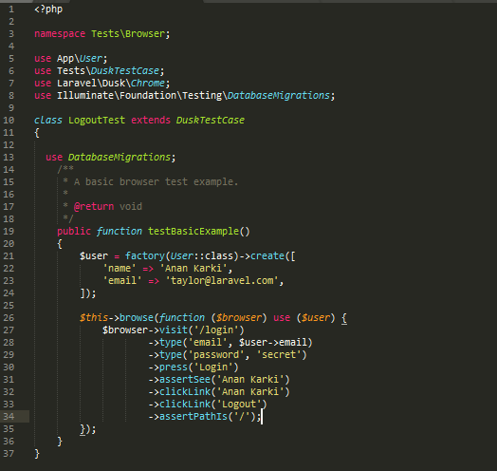

Figure 5 : Logout test script

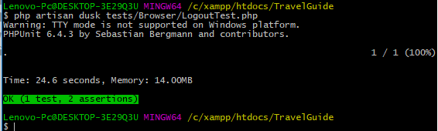

Figure 6 : test result

CrudCreate

|  |  |  |  |  |  |  |
| --- | --- | --- | --- | --- | --- | --- |
| Test Case ID | Test Scenario | Test Steps | Test Data | Expected Results | Actual Results | Pass/Fail |
| TU07 | Create  Crud with valid data | 1. Go to page   /crud/create   1. select Place 2. Enter Description 3. choose image 4. Enter when to visit 5. Enter No of Visitors 6. Enter domestic livingexpense rate 7. Enter domestic transportation_expenses rate 8. Enter international tourist _Livingexpense rate 9. Enter international touristLiving Expenses 10. Enter international Tourist_transportation rate 11. Click create | place = Kathmandu  description = Nice place  image =pasuphati.jpg  NoOf visitor in  jan = 12111  Feb =12312  March=21234  April=1234  May=1234  June =1234  July=1234  August =1234  Sept=12341  oct=1234  Nov=1234  Dec=1234  Domestic tourist_livingexpenses_high rate =12341  Domestic tourist_livingexpenses_LOw rate =12341 | User should be register | As Expected | Pass |
| TU08 | Create Crud with invalid data | 1. Go to page   /crud/create   1. select Place 2. Enter Description 3. choose image 4. Enter when to visit 5. Enter No of Visitors 6. Enter domestic livingexpense rate 7. Enter domestic transportation_expenses rate 8. Enter international tourist _Livingexpense rate 9. Enter international touristLiving Expenses 10. Enter international Tourist_transportation rate 11. Click create | Every filed empty | User should not be able to register | As Expected | Pass |

CrudUpdate

|  |  |  |  |  |  |  |
| --- | --- | --- | --- | --- | --- | --- |
| Test Case ID | Test Scenario | Test Steps | Test Data | Expected Results | Actual Results | Pass/Fail |
| TU09 | Update  Crud with valid data | 1. Go to page   /crud/create   1. select Place 2. Enter Description 3. choose image 4. Enter when to visit 5. Enter No of Visitors 6. Enter domestic livingexpense rate 7. Enter domestic transportation_expenses rate 8. Enter international tourist _Livingexpense rate 9. Enter international touristLiving Expenses 10. Enter international Tourist_transportation rate 11. Click create | place = Kathmandu  description = Nice place  image =pasuphati.jpg  NoOf visitor in  jan = 12111  Feb =12312  March=21234  April=1234  May=1234  June =1234  July=1234  August =1234  Sept=12341  oct=1234  Nov=1234  Dec=1234  Domestic tourist_livingexpenses_high rate =12341  Domestic tourist_livingexpenses_LOw rate =12341 | Crud should be rupdate | As Expected | Pass |
| TU10 | Update Crud with invalid data | 1. Go to page   /crud/create   1. select Place 2. Enter Description 3. choose image 4. Enter when to visit 5. Enter No of Visitors 6. Enter domestic livingexpense rate 7. Enter domestic transportation_expenses rate 8. Enter international tourist _Livingexpense rate 9. Enter international touristLiving Expenses 10. Enter international Tourist_transportation rate 11. Click create | Every filed empty | Crud should not be able to Update | As Expected | Pass |

CrudSearch

|  |  |  |  |  |  |  |
| --- | --- | --- | --- | --- | --- | --- |
| Test Case ID | Test Scenario | Test Steps | Test Data | Expected Results | Actual Results | Pass/Fail |
| TU11 | Search data with valid value | 1. Go to page   /mywelcome   1. Enter Pl ace namw 2. Click Search | Place Name = Kathmandu | Crud should fetsh the data | As Expected | Pass |
| TU12 | Sreach Crud with invalid Data | 1. Go to page   /mywelcome   1. Enter place name 2. Click Search | Place name = aaa | Crud should not fetch the data | As Expected | Pass |

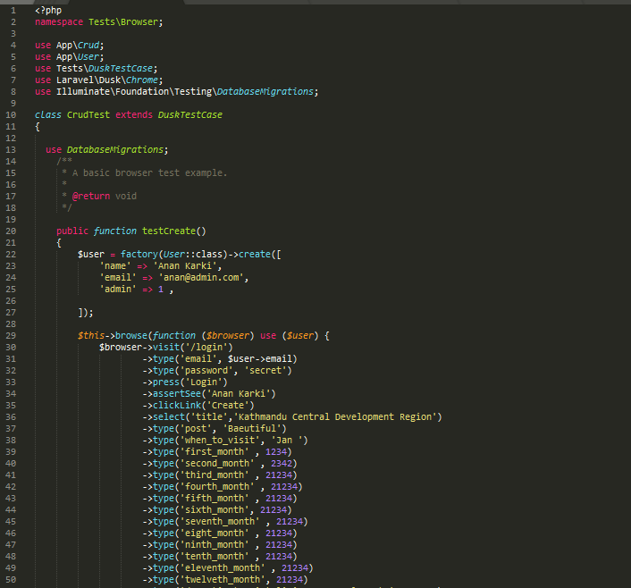

Figure 7 : crud test script

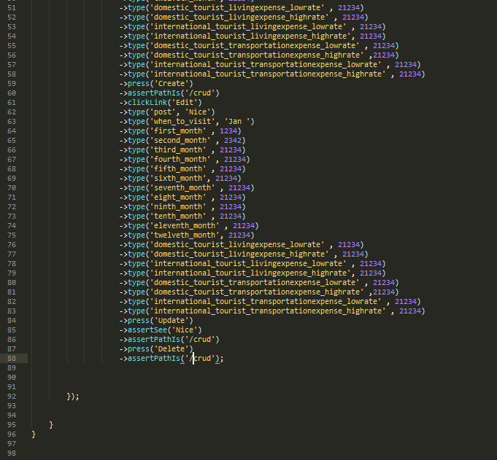

Figure 8: crud test script

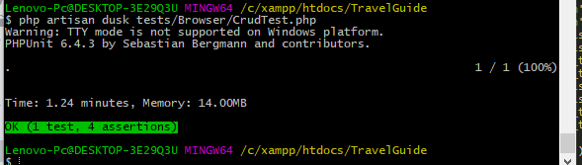

Figure 9 :test result

ReviewTest

ReviewCreate

|  |  |  |  |  |  |  |
| --- | --- | --- | --- | --- | --- | --- |
| Test Case ID | Test Scenario | Test Steps | Test Data | Expected Results | Actual Results | Pass/Fail |
| TU13 | Check Review with valid Data | 1. Go to page   /newReview   1. Enter comment 2. select star 3. Enter Password 4. Click Post | Comment = hello  rating = 4 | User Review should be stored | As Expected | Pass |
| TU14 | Check review with invalid Data | 1. Go to page   /newReview   1. Enter Comment 2. select star 3. Click Post | Comment = rate = | User review should not be stored | As Expected | Pass |

ReviewUpdate

|  |  |  |  |  |  |  |
| --- | --- | --- | --- | --- | --- | --- |
| Test Case ID | Test Scenario | Test Steps | Test Data | Expected Results | Actual Results | Pass/Fail |
| TU15 | Update Review with valid Data | 1. Go to page   /review   1. Enter comment 2. select star 3. Enter Password 4. Click Post | Comment = hello  rating = 1 | User Review should be updated | As Expected | Pass |
| TU16 | Update review with invalid Data | 1. Go to page   /review   1. Enter Comment 2. select star 3. Click Post | Comment = rate = | User review should not be updated | As Expected | Pass |

ReviewView

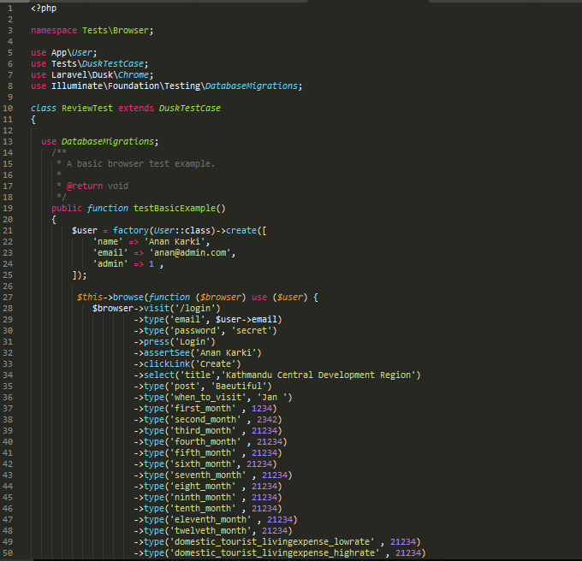

Figure 11 : review testscript

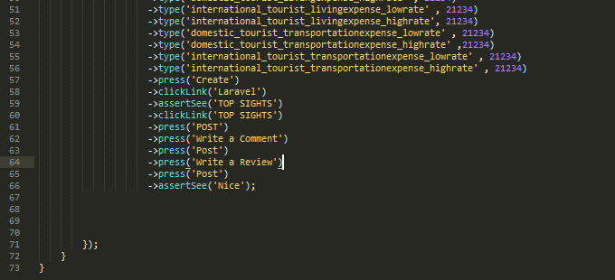

Figure 12: review testscript

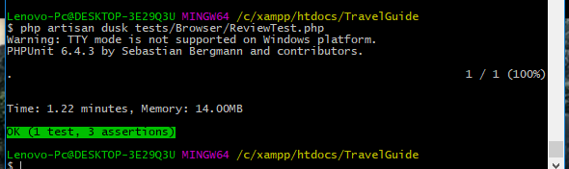

Figure 13 : test result

UpdateUser

|  |  |  |  |  |  |  |
| --- | --- | --- | --- | --- | --- | --- |
| Test Case ID | Test Scenario | Test Steps | Test Data | Expected Results | Actual Results | Pass/Fail |
| TU05 | Check Customer Login with valid Data | 1. Go to page  /login  2 Enter UserName  3 Enter new Email  4 Enter new Password  5 Click Update | Userid = anan@admin.com  Password = aaaaa | User should Login into application | As Expected | Pass |
| TU06 | Check Customer Login with invalid Data | 1. Go to page  /login  2 Enter UserName  3 Enter new Email  4 Enter new Password  5 Click Update | Userid = guru99 Password = glass99 | User should not Login into application | As Expected | Pass |

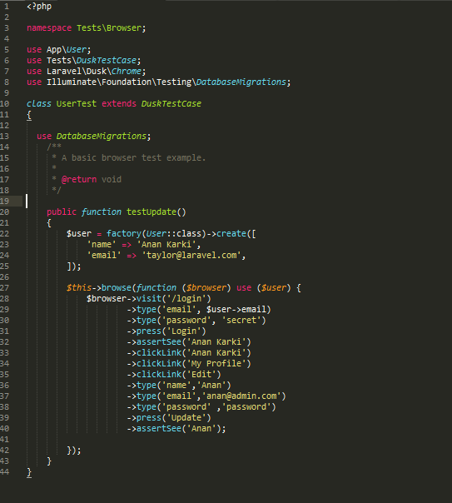

Figure 14 : user testscript

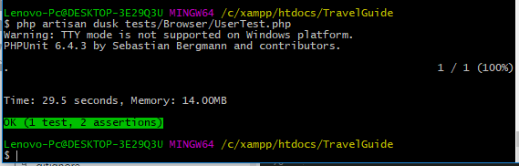

Figure 15 : test result

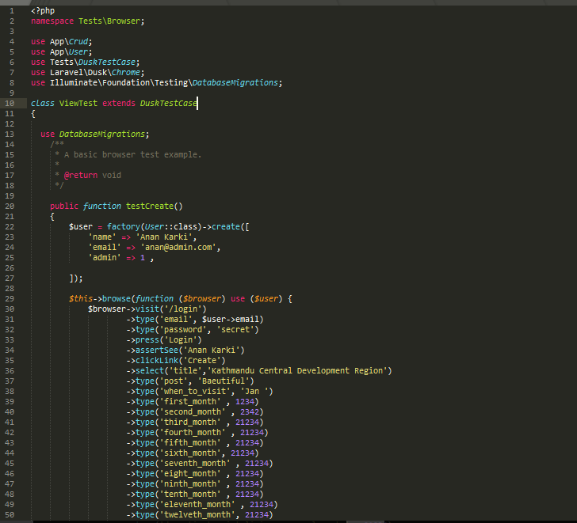

Figure 16:view testscript

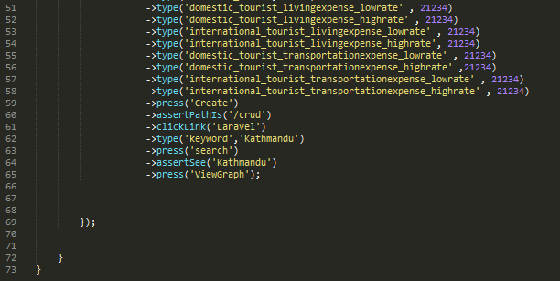

Figure 17 : view testscript

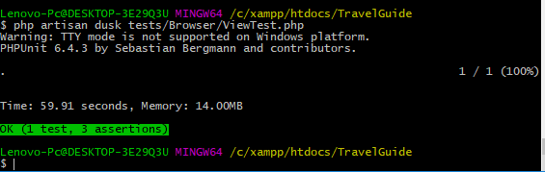

Figure 18 : view Test result

# User Guide

As a Normal User

Search for data

1.Given input in search box

2.Click search or enter 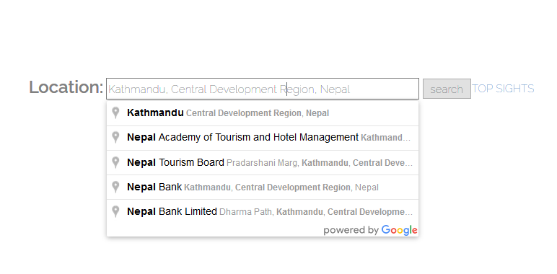

You will recive

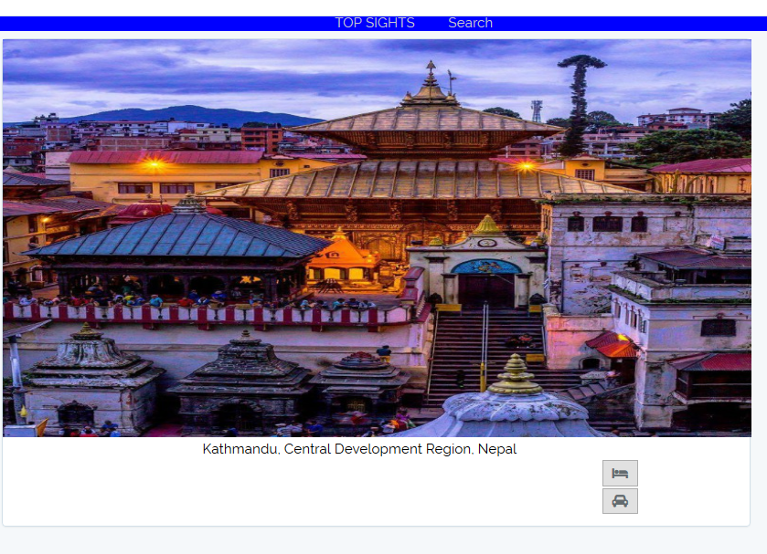

Search for hotel

1 .click the bed icon it will redirect to google search engine

Search for distance and travel time for your location to search location

1.click on car icon you will receive data



Figure 3 : icon



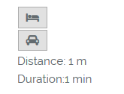

View graph

1. Click on view graph button

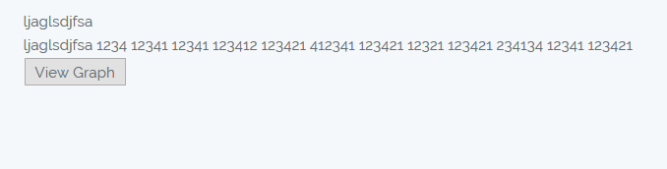

You will receive

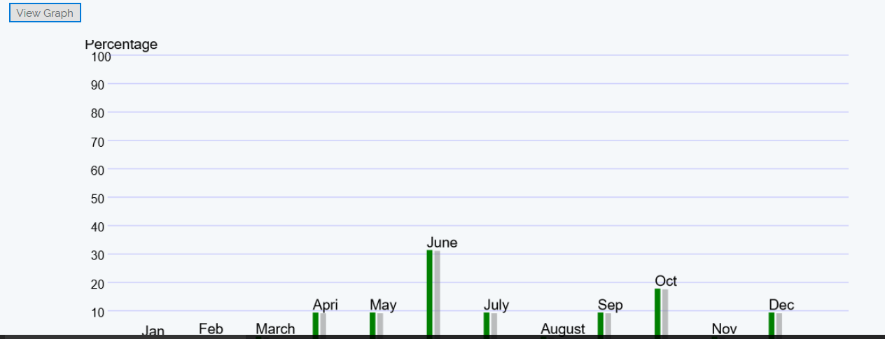

Login and register

1. If has registered click login if not click register



Registration

1. Input valid data in all the field
2. Click Register

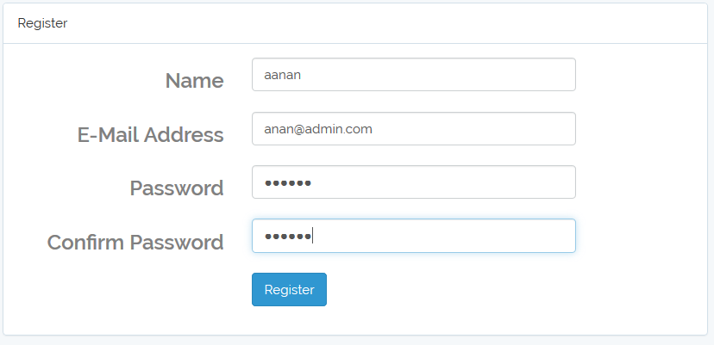

You will reveive email and home view

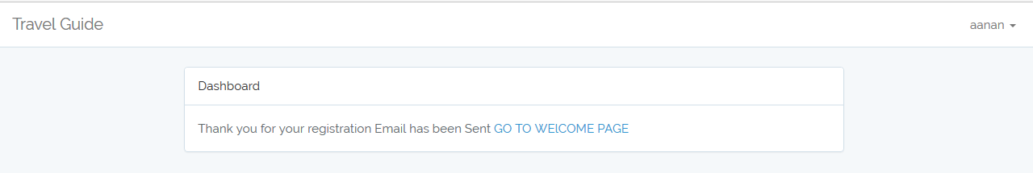

Login

1. Click login



You will receive

1. Login page
2. Input valid data in both field
3. Press login button

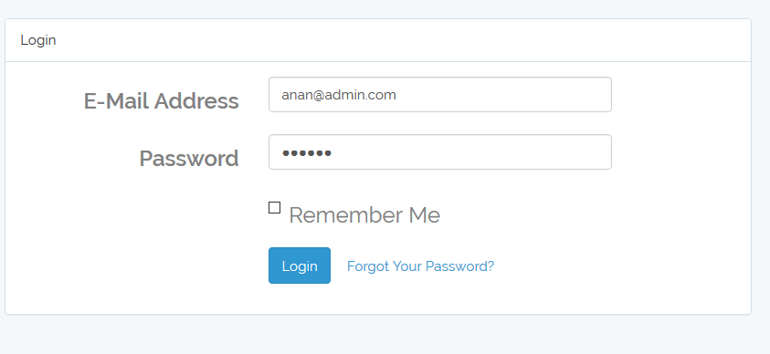

Logout

1. Click on your name
2. Click Logout

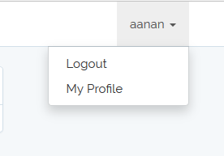

You will be logged out

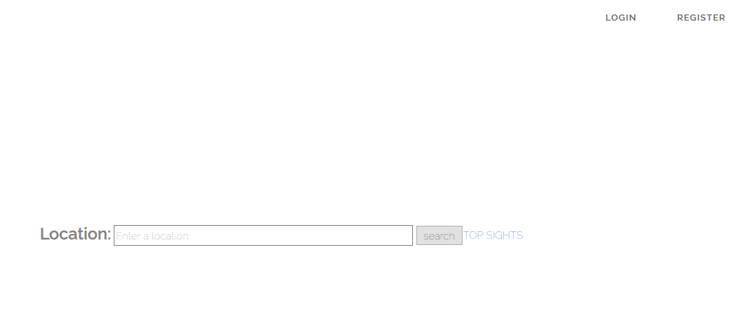

Update you profile

1. Click on your name and click My Profile



You will receive

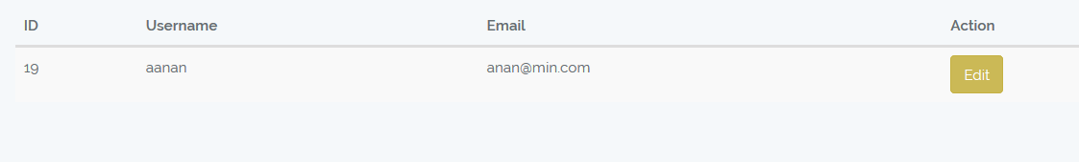

1. Click edit button

You will receive

1. Enter your new Profile
2. Press update button

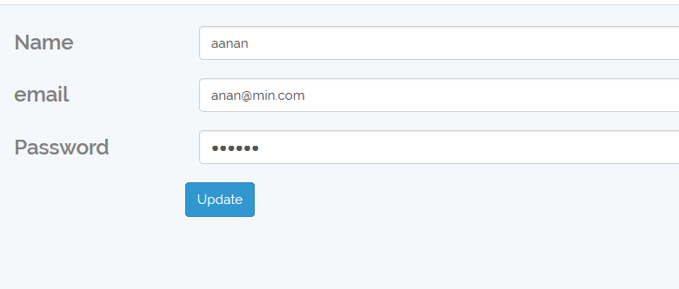

Visit sights

1. Go to home page click Top sights or click Top sights in nav bar

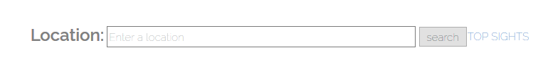



You wll receive

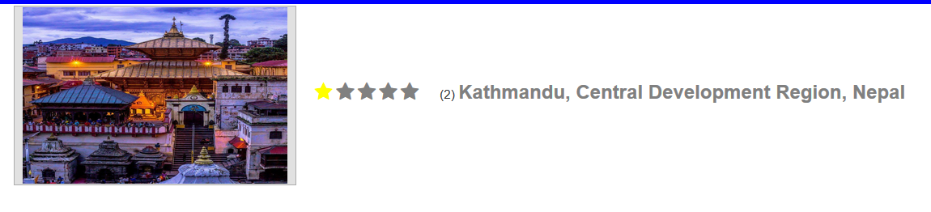

Write a review

1.Your have to login first you hadn't

2.Go to Top sights view



Your will receive

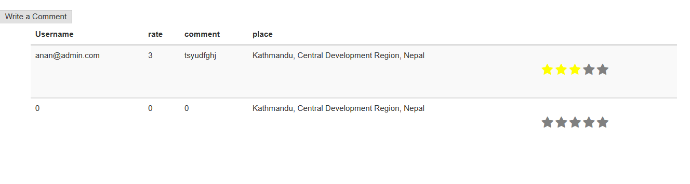

1. Click on write a comment button if you want to write a review

You will receive pop up

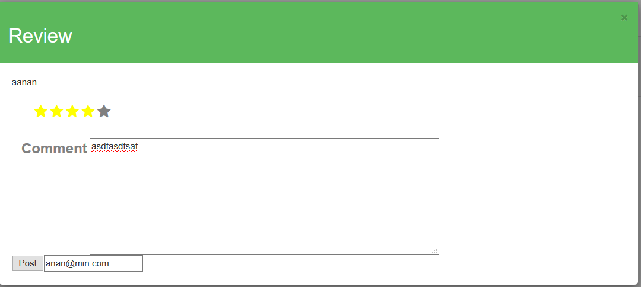

1. Click post button to post and cancel icon to cancel the post

You will receive

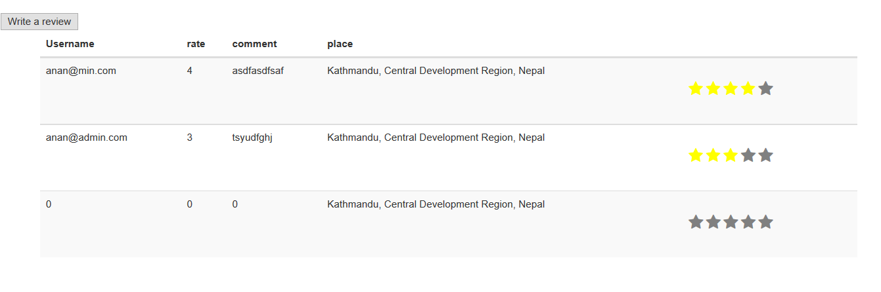

Update review

1 .click on write a review button

You will receive pop up

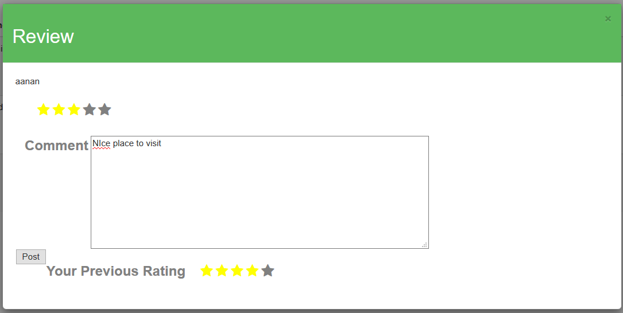

1. Click on post

You will receive

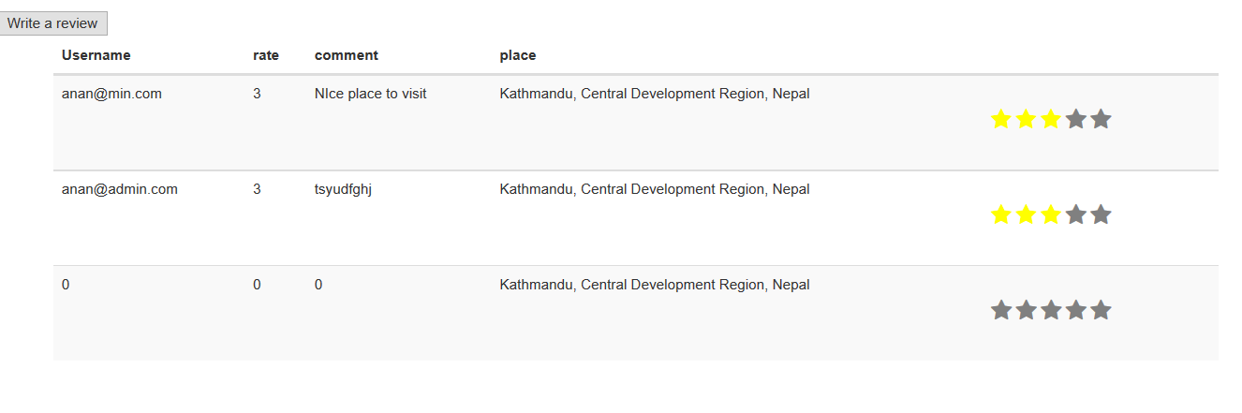

AS an Administrator

1. Enter your valid data
2. Click login



You will receive

1. Click create to create
2. Click update to update
3. Click view to view

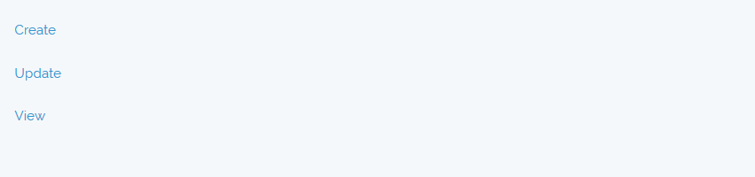

Create

1. Input all the valid data
2. Click on create button

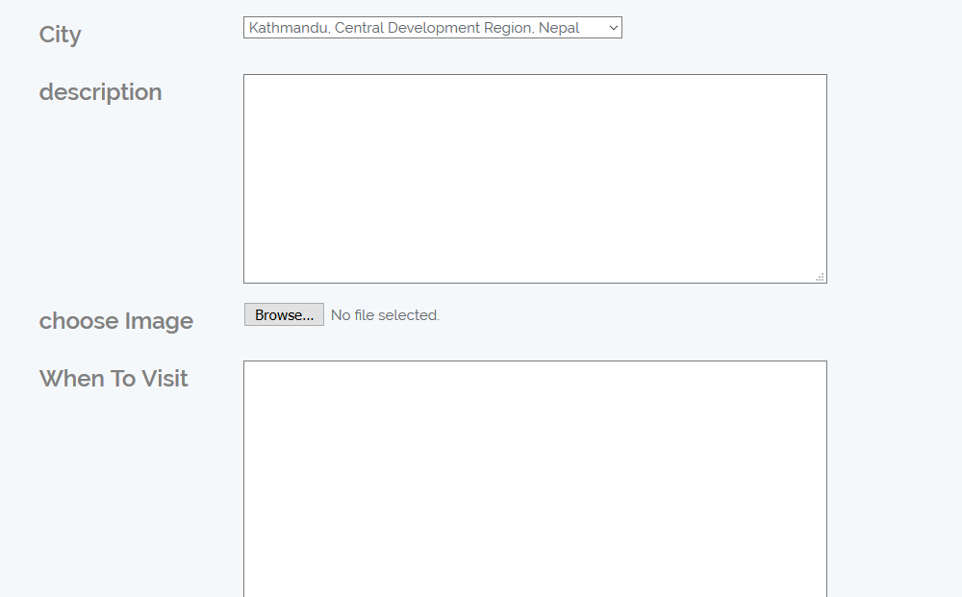

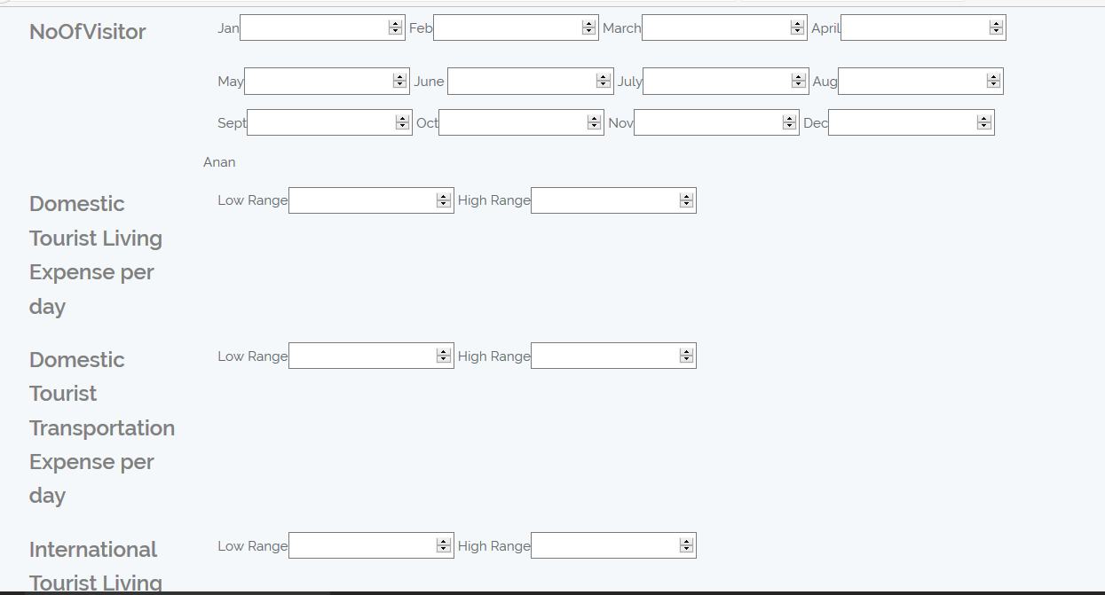

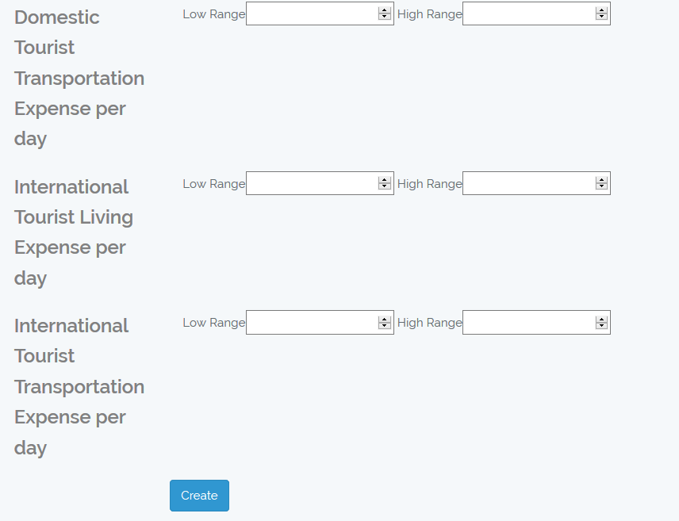

You will receive

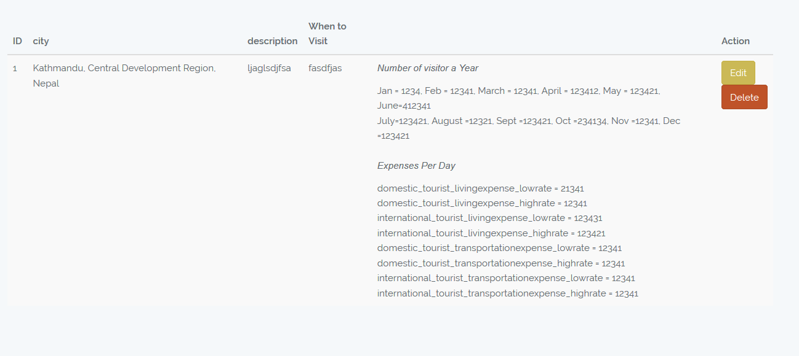

Update

1. Click on edit button
2. Enter your new data and press update button

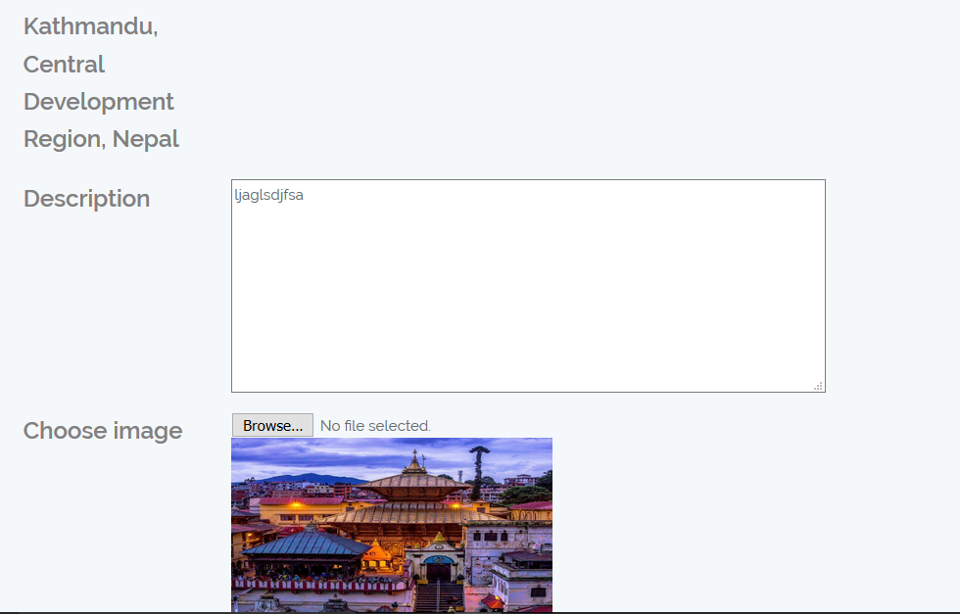

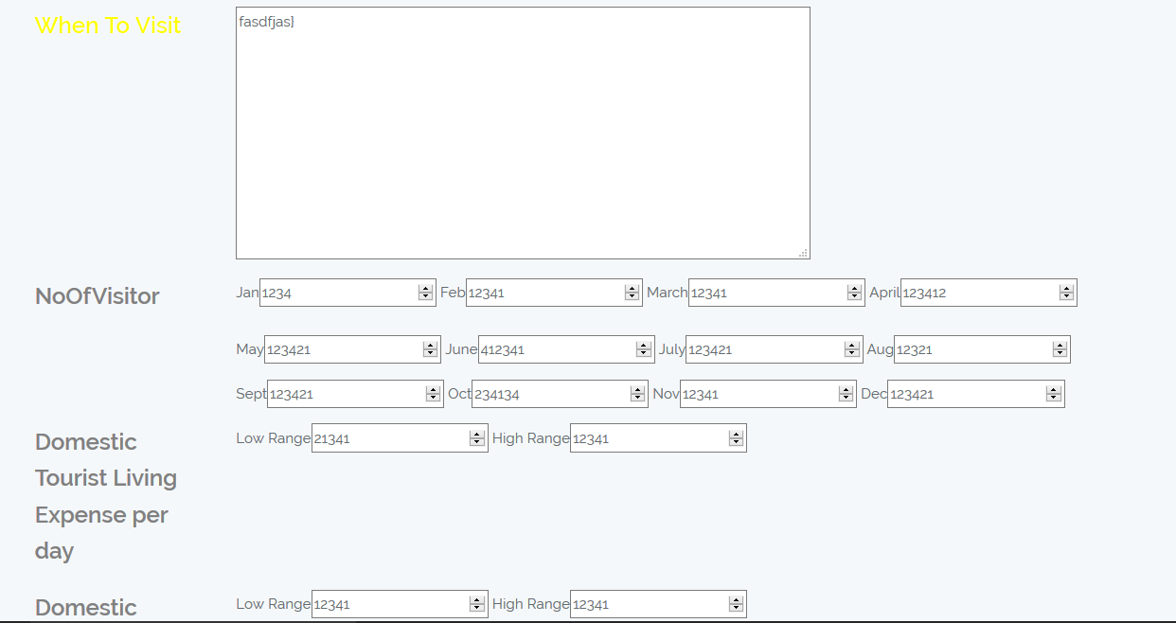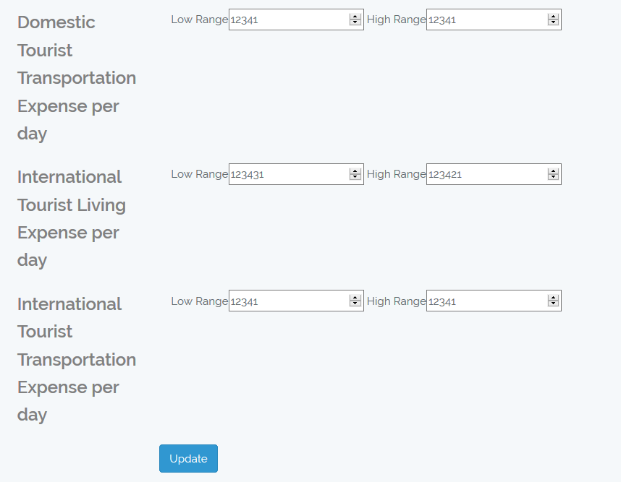

View

Click on view icon

You will receive

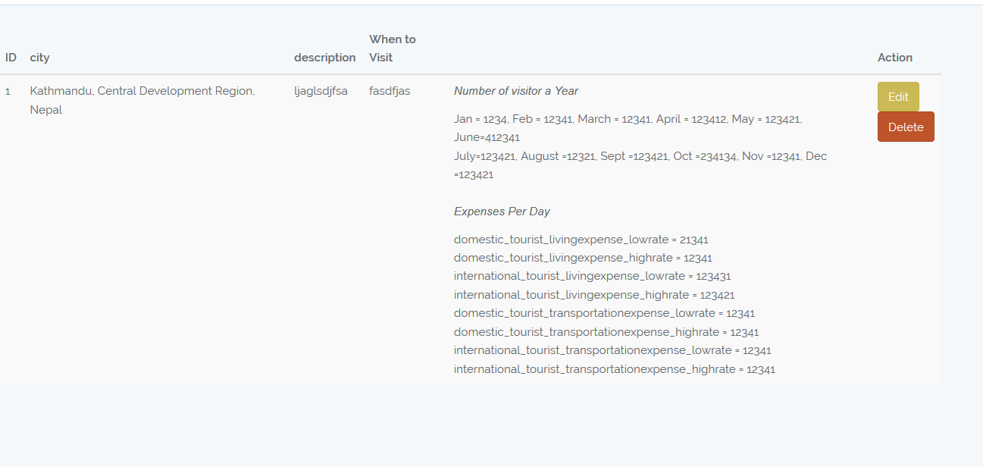

If you want to delete you data click Delete button